TO | Interested Parties
FROM | John Fairbank and Rick Sklarz  FM3 Research
RE: | City of San Diego Ballot Measure Survey
DATE | October 31, 2025

A survey of City of San Diego voters likely to cast a ballot in the November 2026 election shows the public is highly concerned about the direction of their city and believes San Diego has a significant need for additional funding to provide essential services that residents need and want. By a margin of three to one, voters think San Diego is “off on the track” (62%) compared to just two in ten (22%) who see their city as “headed in the right direction.” Furthermore, nearly two-thirds (64%) identify the city as having a “great” or “some” need for additional funding compared to fewer than three in ten (28%) who say “a little” or “no need”. (See Figure 1)

Figure 1: View of San Diego & the City’s Need for Additional Funds

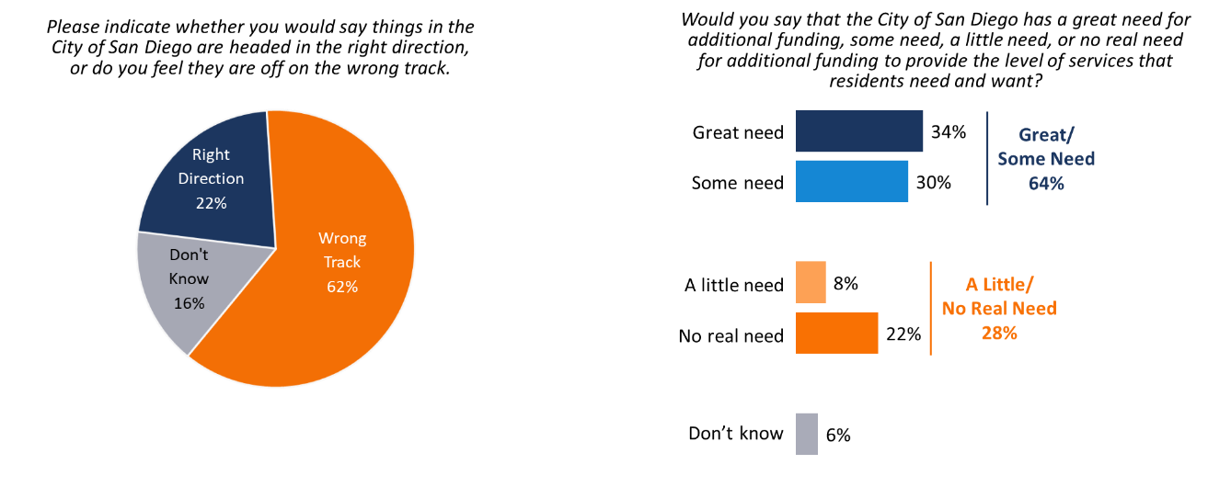

San Diegans prioritize using funds raised by a local ballot measure to address major issues facing their city. As Figure 3 illustrates, more than three in four voters identify the following uses as extremely or very important uses of funds raised by the proposed ballot measure: protecting local water resources from contaminated runoff, fixing unsafe and outdated infrastructure, reducing the threat of wildfires, and maintaining 911 emergency response services.
Figure 3: City Service Priorities
% Rating "Extremely" or "Very Important"
Use of Funds | % Extremely/  Very Important
- Protect beaches/bays from contaminated runoff | 85%
Repairing infrastructure | 83%
Improving brush clearing/wildfire prevention | 81%
Retaining first-respondents/rapid 911 response | 78%
Protect safe clean drinking water by replacing  deteriorating/asbestos contaminated pipes and sewers | 76%

In sum, these survey results show San Diego voters understand their city faces significant challenges to maintain essential services that are important to residents’ quality of life. To address this problem, a majority supports a ballot measure to raise the city’s sales tax in order to fund critical infrastructure repair, public safety, and other vital city services that are critical to residents’ and communities’ health and well-being. The inclusion of strong accountability provisions and that the measure would be placed on the ballot via petition and independent of city government gives voters greater confidence that funds would be utilized effectively, efficiently, and as promised.

Methodology: From October 18-23, 2025, Fairbank, Maslin, Maullin, Metz & Associates (FM3) conducted a survey among 718 City of San Diego voters likely to cast a ballot in the November 2026 statewide election. The survey was conducted using a dual-mode methodology where voters were contacted by telephone (cellular and landlines), email or text message. Interviews were conducted online and via telephone by live interviewers in English and Spanish. The margin of error for the full sample is +/-4.0% at the 95% confidence level. Voters in City Council Districts 5, 6 and 7 were oversampled. Not all results will sum to 100% due to rounding.

